22.60: a)
b) Inside a hollow shell, the 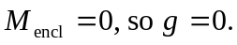
c) Inside a uniform spherical mass:
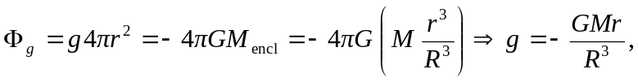
which is linear in

